desserts
Aperitif Tiramisu
apolonia-blend coffee | candied crust
12⁸⁸
Cocchi Dopo Teatro, Piedmont, Italy 13⁸⁸

Limoncello Cheesecake
ricotta ice cream | lemon jam
13⁸⁸
Keller ‘Pius’ Auslese, Rheinhessen | Germany 19⁸⁸

Creamsicle Semifreddo
orange | vanilla | olive oil
12⁸⁸
Quintarelli Passito ‘Amabile del Cere’, Veneto | Italy 31⁸⁸

Sticky Toffee Pudding
mascarpone | brown sugar
12⁸⁸
Valdespino Pedro Ximénez | Spain 19⁸⁸

The Pistachio
emerald sicilian variations
10⁸⁸
Valdespino Moscatel, Andalucia, Spain 14⁸⁸

Gelatos & Sorbets
daily selection
4⁸⁸

desserts
Aperitif Tiramisu
apolonia-blend coffee | candied crust
12⁸⁸
Cocchi Dopo Teatro, Piedmont, Italy 13⁸⁸

Limoncello Cheesecake
ricotta ice cream | lemon jam
13⁸⁸
Keller ‘Pius’ Auslese, Rheinhessen | Germany 19⁸⁸

Creamsicle Semifreddo
orange | vanilla | olive oil
12⁸⁸
Quintarelli Passito ‘Amabile del Cere’, Veneto | Italy 31⁸⁸

Sticky Toffee Pudding
mascarpone | brown sugar
12⁸⁸
Valdespino Pedro Ximénez | Spain 19⁸⁸

The Pistachio
emerald sicilian variations
10⁸⁸
Valdespino Moscatel, Andalucia, Spain 14⁸⁸

Gelatos & Sorbets
daily selection
4⁸⁸
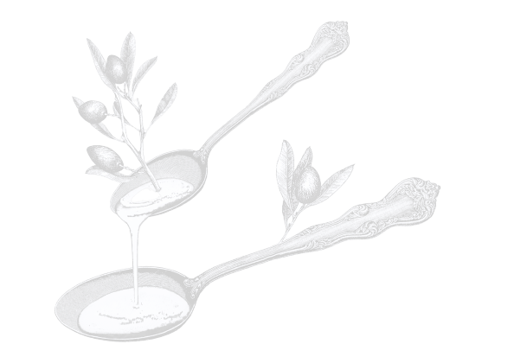
Negroni Amaro
veneto | italy

Gorki List
subotica | serbia

Gran Classico
bern | switzerland

Malört
chicago | illinois

Sfumato ‘Rabarbaro’
cappelletti | italy

Bordiga ‘Centum Herbis’
cuneo | italy

Montenegro
bologna | italy

Génépy
savoy | france

Sfumato ‘Rabarbaro’
cappelletti | italy

Bordiga ‘Centum Herbis’
cuneo | italy

Montenegro
bologna | italy

Génépy
savoy | france

apolonia blend coffee
dessert wine
Negroni Amaro
veneto | italy

Gorki List
subotica | serbia

Gran Classico
bern | switzerland

Malört
chicago | illinois

amari & so
14⁸⁸
apolonia blend coffee
dessert wine
amari & so
14⁸⁸
Punt e Mes 16⁸⁸
carpano | lombardy | italy

Palo Cortado Don Nuño Sherry 16⁸⁸
lustau | jerez de la frontera | spain

‘Promesa’ Moscatel Sherry 14⁸⁸
valdespino | jerez de la frontera | spain

‘El Candado’ PX Sherry 19⁸⁸
valdespino | jerez de la frontera | spain

Chenin Blanc ‘Clos de la Bergerie’ 12⁸⁸
2022 domaine de la bergerie | loire valley | france

Punt e Mes 16⁸⁸
carpano | lombardy | italy

Palo Cortado Don Nuño Sherry 16⁸⁸
lustau | jerez de la frontera | spain

‘Promesa’ Moscatel Sherry 14⁸⁸
valdespino | jerez de la frontera | spain

‘El Candado’ PX Sherry 19⁸⁸
valdespino | jerez de la frontera | spain

Chenin Blanc ‘Clos de la Bergerie’ 12⁸⁸
2022 domaine de la bergerie | loire valley | france

Espresso Latte Cappuccino
4⁸⁸ 6⁸⁸ 6⁸⁸

Espresso Latte Cappuccino
4⁸⁸ 6⁸⁸ 6⁸⁸

